Meeting 26
Course / Class #: CECS 4800

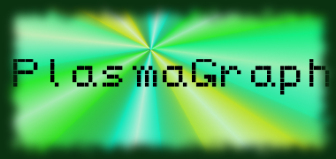
Date: 10 April 2014
Project Name: PlasmaGraph

Has been done:
- Bug fixing
- Help file
- Interpolation grouping (doubles only)
- Meeting with client
What will be done:
- Bug fixing (String column graphing, index out of bound exception handling)
- Test documentation first draft
- Start testing with final matlab file format.

Materials Used: 2x Computers, Internet connections, Microsoft Visio / Dia (Diagramming Tools), Eclipse / NetBeans IDE (Programming Tools).

Group Members: ________________________________
Gerardo A. Navas

________________________________
Daniel Quintini
Professor:

________________________________
Prof. Luis A. Ortiz

